UNIFIED MECHANICS · RESEARCH PROGRAMME
Interpretations
The Golden Skeleton of E₈
Why the golden contraction and the E₈ carrier are one structure · the covolume currency of the observer · a candidate derivation of the √3 coupling
JOSEPH SHIELDS · WITH CLAUDE AS RESEARCH ASSISTANT
16 JULY 2026 · WORKING NOTE — INTERPRETATION LAYER

1. THE FINDING
The framework has always carried two structural commitments that looked independent: the golden fixed point selects the dynamics (r = 1/(2φ) per contraction), and the first E₈ shell carries the vacuum readout (240 roots, forty snowflake cells). Volume 08 derived the carrier from self-description. This note reports that the two commitments were never independent at all — the golden ratio is already inside the carrier, visible in the exact projection the observer-readout construction uses.
In the Coxeter plane — the same plane in which the Snowflake Observatory draws the shell — the 240 roots fall on eight rings of thirty. Computed directly from the root coordinates: the eight radii pair into exactly four golden pairs. R2/R1, R6/R3, R7/R4 and R8/R5 all equal φ to within 6 × 10⁻⁷, which is the numerical precision of the eigenplane computation, not an approximation in the structure.
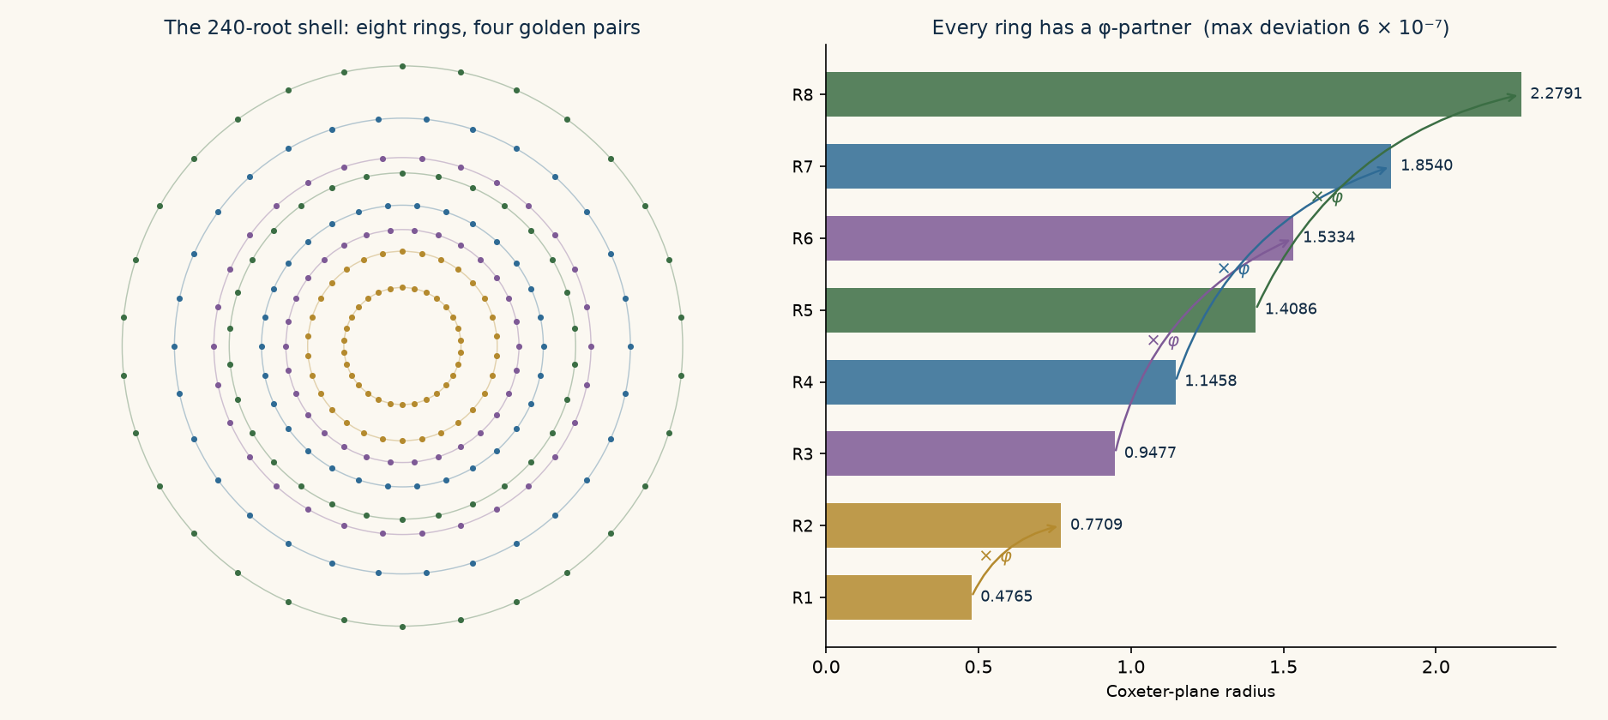
The observer projection of the 240-root shell. Colour marks the four golden ring-pairs; every ring maps to its partner under multiplication by φ.
RECORD — GOLDEN RING PAIRING — Computed 16 July 2026 from the standard doubled-coordinate E₈ roots and the Coxeter element built from the Bourbaki simple roots. Eight rings of 30; four ratio pairs equal to φ with maximum deviation 6 × 10⁻⁷. Reproducible from the archived script.
This is the two-dimensional fingerprint of a known deep fact: E₈ is the icosian lattice — quaternions with coefficients in the golden ring ℤ[φ] — and its root system folds onto two copies of the H₄ 600-cell scaled by φ (the construction underlying Dechant's spinor result already cited in Volume 05's references). The framework did not import the golden ratio and then, separately, import E₈. There is one ℤ[φ]-object, seen twice.

2. ONE STRUCTURE, NOT TWO POSTULATES
This tightens the Volume 08 selection theorem in a satisfying way. Self-description (Λ* = Λ) selected E₈ among even lattices. But the framework's dynamics demanded more: a carrier able to realize golden whole-part closure without remainder. The icosian structure is exactly that compatibility — E₈ is not merely the unique self-dual carrier, it is a ℤ[φ]-module, a lattice whose own scaling symmetry in the observer plane is the golden map. The dynamical postulate (golden contraction) and the kinematic postulate (E₈ alphabet) are two shadows of the same object, and either one now motivates the other.

2.1 A reading of r = 1/(2φ)
The marginal contraction weight has always been stated algebraically: r = 1/(2φ), the reciprocal of the doubled golden ratio, equivalently (√5 − 1)/4. The golden pairing offers a geometric reading. In the observer plane, one golden step (× 1/φ) maps each ring onto its inner partner. A channel relation is bidirectional — every root shares its record with its reverse. One golden step distributed over the two orientations of a root is 1/φ ÷ 2 = 1/(2φ). The contraction weight is one ring-step per orientation.
CONJECTURED — CONTRACTION FROM GEOMETRY — The identification r = (one golden ring-step)/(two orientations) is an interpretation consistent with the projection geometry, not yet a derivation. To promote it: show that the readout dynamics acts on ring-pairs by the φ-map and that the marginal weight per root follows from equipartition over orientation. If instead the dynamics acts on some other grading of the shell, this reading fails while the ring pairing itself remains a fact.

3. THE COVOLUME CURRENCY
Volume 08 identified √3 — the covolume of the local A₂ carrier, the measure of its failure to be self-dual — as the factor the observer keeps paying. Decoding the boundary-mismatch constant of Main Monograph §18 extends this into a pattern. The monograph states ΔB = −2√2 + 5/4 + 3√5/4 = 0.098623858379. This is exactly:
ΔB = (√5 · φ²) / 2 − √8
— an algebraic identity, not an approximation. And the two square roots are not arbitrary surds: √5 is the covolume (root-discriminant) of the golden description ring ℤ[φ], and √8 = 2√2 is the covolume of the silver description ring ℤ[√2]. The gold–silver boundary mismatch is a difference of description-lattice covolumes: the golden side offers measure √5·φ²/2 per cycle, the silver side absorbs measure √8, and the interface keeps the change. Rubbing is a covolume imbalance.
Constant | Value | Lattice / ring | Role in the framework
√3 | 1.732051 | A₂ carrier (disc 3) | Local self-duality defect; divides the Λ readout; multiplies the interface scale (SPARC)
√5 | 2.236068 | ℤ[φ], golden ring (disc 5) | Covolume of the golden description ring; first term of ΔB
√8 = 2√2 | 2.828427 | ℤ[√2], silver ring (disc 8) | Covolume of the silver description ring; second term of ΔB
1 (unimodular) | 1.000000 | E₈ (disc 1) | The only self-describing carrier: description = existence

RECORD — EXACT IDENTITY — √5(3+√5)/4 = (5+3√5)/4 = 5/4 + 3√5/4, hence ΔB = √5φ²/2 − √8 exactly. Verified symbolically and numerically to machine precision, 16 July 2026.
CONJECTURED — COVOLUME CURRENCY — Every dimensionless observer-facing constant in the closure chain is a rational combination of covolumes of the description lattices in play: √3 (carrier), √5 (gold), √8 (silver), 1 (E₈). This is a falsifiable pattern claim: the next independently derived constant of the framework must decompose in this currency or the thesis dies.

4. A CANDIDATE DERIVATION OF THE √3 COUPLING
Volume 08 left one red obligation: derive the factor √3 in the interface scale √3·cH₀ΔB from the boundary semantics, without reference to SPARC. The covolume reading suggests where it lives. The dimensional step of Main Monograph §18.2 — a = cHΔB — treats the two available boundary quantities (the universal speed and the recurrence clock) as an orthonormal coordinate pair: implicitly, a description frame of covolume 1. But the framework's own Theorem forces the local observer carrier to be the A₂ pair at 120°, covolume √3. The same mismatch rate, re-expressed on the forced carrier instead of the naive orthonormal frame, acquires exactly the ratio of the two covolumes: a = (√3/1) · cHΔB.
Stated as mechanism: the dimensional analysis was performed in the wrong basis — the very 'unforced independent coordinate' the Snowflake paper's Theorem 2 prohibits. Correcting the basis is not a new physical ingredient; it is the enforcement of an existing theorem at a step that predated it.
CONDITIONAL-CANDIDATE — BASIS CORRECTION — If the interface work integral is shown to be defined per unit carrier cell (covolume √3) while the clock normalization cH is defined per orthonormal frame (covolume 1), then a = √3·cHΔB follows with no new constant, and the SPARC agreement of Volume 08 becomes a zero-fit success. The converse reading (work per orthonormal frame, record per cell) would give a = cHΔB/√3 ≈ 4.0 × 10⁻¹¹, which the data exclude. The obligation is now sharp: derive which side of the interface carries the cell measure. Until that is done this remains a candidate, not a result.
Two consistency checks favour the candidate. First, it is structurally parallel to the Λ readout, where the response two-form is normalized per primitive cell — there the cell measure enters as 1/√3 because the record is a density over the boundary; here the interface delivers work into the cell, so the measure enters as √3. One defect, paid in opposite directions by a record and a force. Second, the resulting dimensionless coefficient √3·ΔB = 0.1708 sits beside the forty-year-old unexplained folklore value a₀ ≈ cH₀/2π (0.1592) — close enough to explain why the folklore worked, distinct enough to be testable.

5. WHAT THIS BUYS, AND WHAT IT DOES NOT
Bought: the golden dynamics and the E₈ carrier are unified into one ℤ[φ]-structure, removing an apparent double postulate; the mismatch constant ΔB acquires a structural meaning (covolume imbalance) instead of being a bare surd; and the √3 coupling has a candidate derivation with a sharp remaining obligation and a data-excluded converse. Not bought: none of this yet upgrades any physical claim grade. The ring pairing and the ΔB identity are mathematical records — certain, but silent about nature. The currency thesis and the basis correction are conjectures with named falsifiers. The framework's empirical standing still rests where Volume 08 left it: on the frozen predictions P1–P3.
One proposed mechanism was tested and failed, and the failure is worth recording. If each A₂ cell drew its roots from the golden ring-pairs in a fixed pattern, the contraction reading of Section 2.1 would inherit a mechanism from the exact cover. It does not: across three independent exact covers the ring composition of the forty cells varies freely (25–29 distinct ring profiles, different distributions per cover). The cover does not canonically respect the golden pairing — exactly as Volume 05's Lemma 4 (cover independence) would suggest. The golden pairing is a property of the shell's grading, not of any particular cell partition, and any promotion of Section 2.1 must act there.
RECORD — NEGATIVE: COVER-RING INDEPENDENCE — Tested 16 July 2026 on exact covers generated with three independent random seeds. Cell ring-profiles are cover-dependent; no canonical pair-structure exists at cell level. Consistent with Lemma 4 of Volume 05.
The sharpest next steps, in order: derive which side of the gold–silver interface carries the A₂ cell measure (this single derivation would convert the SPARC agreement into the framework's second zero-fit success); and recompute the genesis-sequence weights of Main Monograph §18 directly in covolume language to test the currency thesis on constants not yet examined.
UNIFIED MECHANICS · INTERPRETATIONS · 2026

